Paper’s title should be the fewest possible words that accurately describe the content of the paper (Center, Bold, 16pt)

Abdel‑Rahman Hedar^{1,2}, Patricia Melin³, Kennedy Okokpujie⁴ (10 pt)
¹Department of Computer Science, Faculty of Computers & Information, Assiut University, Assiut, Egypt (8 pt)
²Department of Computer Science in Jamoum, Umm Al-Qura University, Makkah, Saudi Arabia
³Division of Graduate Studies, Tijuana Institute of Technology, Tijuana, Mexico
⁴Department of Electrical and Information Engineering, College of Engineering, Covenant University, Ota, Nigeria

Article Info |  | ABSTRACT (10 PT)
Article history:  Received month dd, yyyy  Revised month dd, yyyy  Accepted month dd, yyyy |  | An abstract is often presented separate from the article, so it must be able to stand alone. A well-prepared abstract enables the reader to identify the basic content of a document quickly and accurately, to determine its relevance to their interests, and thus to decide whether to read the document in its entirety. The abstract should be informative and completely self-explanatory, provide a clear statement of the problem, the proposed approach or solution, and point out major findings and conclusions. The Abstract should be 100 to 200 words in length. References should be avoided, but if essential, then cite the author(s) and year(s). Standard nomenclature should be used, and non-standard or uncommon abbreviations should be avoided, but if essential they must be defined at their first mention in the abstract itself. No literature should be cited. The keyword list provides the opportunity to add 5 to 7 keywords, used by the indexing and abstracting services, in addition to those already present in the title (9 pt).
Keywords:
First keyword
Second keyword
Third keyword
Fourth keyword
Fifth keyword
 |  | This is an open access article under the CC BY-SA license.
Corresponding Author:
Kennedy Okokpujie
Department of Electrical and Information Engineering, College of Engineering, Covenant University
Km. 10 Idiroko Road, Canaan Land, Ota, Ogun State, Nigeria
Email: kennedy.okokpujie@covenantuniversity.edu.nga

- INTRODUCTION (10 PT)
The main text format consists of a flat left-right columns on A4 paper (quarto). The margin text from the left and top are 2.5 cm, right and bottom are 2 cm. The manuscript is written in Microsoft Word, single space, Time New Roman 10 pt, and maximum 12 pages for original research article, or maximum 16 pages for review/survey paper, which can be downloaded at the website: http://ijai.iaescore.com.
A title of article should be the fewest possible words that accurately describe the content of the paper. The title should be succinct and informative and no more than about 12 words in length. Do not use acronyms or abbreviations in your title and do not mention the method you used, unless your paper reports on the development of a new method. Titles are often used in information-retrieval systems. Avoid writing long formulas with subscripts in the title. Omit all waste words such as "A study of ...", "Investigations of ...", "Implementation of ...”, "Observations on ...", "Effect of.....", “Analysis of …”, “Design of…”, etc.
A concise and factual abstract is required. The abstract should state briefly the purpose of the research, the principal results and major conclusions. An abstract is often presented separately from the article, so it must be able to stand alone. For this reason, References should be avoided, but if essential, then cite the author(s) and year(s). Also, non-standard or uncommon abbreviations should be avoided, but if essential they must be defined at their first mention in the abstract itself. Immediately after the abstract, provide a maximum of 7 keywords, using American spelling and avoiding general and plural terms and multiple concepts (avoid, for example, 'and', 'of'). Be sparing with abbreviations: only abbreviations firmly established in the field may be eligible. These keywords will be used for indexing purposes.
Indexing and abstracting services depend on the accuracy of the title, extracting from it keywords useful in cross-referencing and computer searching. An improperly titled paper may never reach the audience for which it was intended, so be specific.
The Introduction section should provide: i) a clear background, ii) a clear statement of the problem, iii) the relevant literature on the subject, iv) the proposed approach or solution, and v) the new value of research which it is innovation (within 3-6 paragraphs). It should be understandable to colleagues from a broad range of scientific disciplines. Organization and citation of the bibliography are made in Institute of Electrical and Electronics Engineers (IEEE) style in sign [1], [2] and so on. The terms in foreign languages are written italic (italic). The text should be divided into sections, each with a separate heading and numbered consecutively [3]. The section or subsection headings should be typed on a separate line, e.g., 1. INTRODUCTION. A full article usually follows a standard structure: 1. Introduction, 2. The Comprehensive Theoretical Basis and/or the Proposed Method/Algorithm (optional), 3. Method,
4. Results and Discussion, and 5. Conclusion. The structure is well-known as IMRaD style.
Literature review that has been done author used in the section "INTRODUCTION" to explain
the difference of the manuscript with other papers, that it is innovative, it are used in the section "METHOD" to describe the step of research and used in the section "RESULTS AND DISCUSSION" to support the analysis of the results [2]. If the manuscript was written really have high originality, which proposed a new method or algorithm, the additional section after the "INTRODUCTION" section and before the "METHOD" section can be added to explain briefly the theory and/or the proposed method/algorithm [4].

- METHOD (10 PT)
Explaining research chronological, including research design, research procedure (in the form of algorithms, Pseudocode or other), how to test and data acquisition [5]–[7]. The description of the course of research should be supported references, so the explanation can be accepted scientifically [2], [4]. Figures 1-2 and Table 1 are presented center, as shown below and cited in the manuscript [5], [8]–[13]. The settlement curves produced at SG1 has been illustrated in Figure 2(a) and SG2 has been illustrated Figure 2(b).

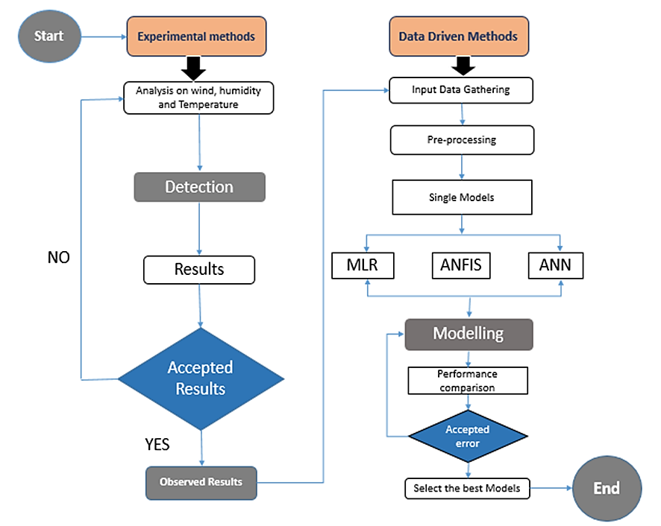

Figure 1. Shows the flowchart of the AI-based models and experimental methods applied
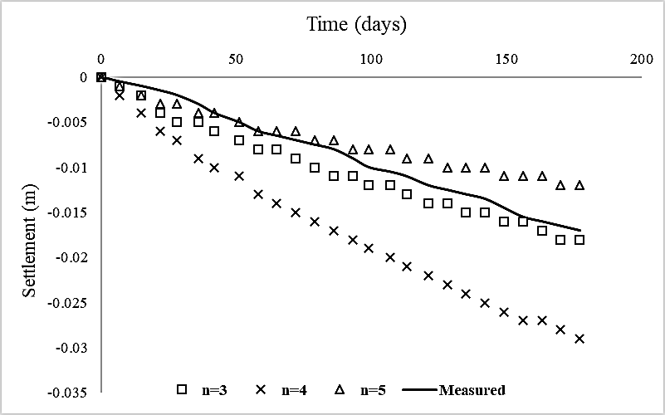
(a)

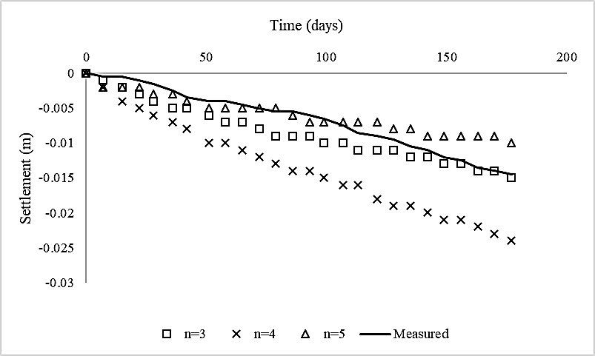
(b)

Figure 2. The relationship of soil settlement and time for (a) SG1 and (b) SG2

Table 1. The performance of ...
Variable | Speed (rpm) | Power (kW)
x | 10 | 8.6
y | 15 | 12.4
z | 20 | 15.3

- RESULTS AND DISCUSSION (10 PT)
In this section, it is explained the results of research and at the same time is given
the comprehensive discussion. Results can be presented in figures, graphs, tables and others that make
the reader understand easily [14], [15]. The discussion can be made in several sub-sections.

3.1. Sub section 1
Equations should be placed at the center of the line and provided consecutively with equation numbers in parentheses flushed to the right margin, as in (1). The use of Microsoft Equation Editor or MathType is preferred.

$E_{v}-E=\frac{h}{2.m} (k_{x}^{2}+k_{y}^{2}$) (1)

All symbols that have been used in the equations should be defined in the following text.

3.2. Sub section 2
Proper citation of other works should be made to avoid plagiarism. When referring to a reference item, please use the reference number as in [16] or [17] for multiple references. The use of ”Ref [18]...” should be employed for any reference citation at the beginning of sentence. For any reference with more than 3 or more authors, only the first author is to be written followed by et al. (e.g. in [19]). Examples of reference items of different categories shown in the References section. Each item in the references section should be typed using 8 pt font size [20]–[25].

3.2.1. Subsub section 1
yy
3.2.2. Subsub section 2
zz

- CONCLUSION (10 PT)
Provide a statement that what is expected, as stated in the "INTRODUCTION" section can ultimately result in "RESULTS AND DISCUSSION" section, so there is compatibility. Moreover, it can also be added the prospect of the development of research results and application prospects of further studies into the next (based on result and discussion).

ACKNOWLEDGEMENTS (10 PT)
Author thanks ... . In most cases, sponsor and financial support acknowledgments.

REFERENCES (10 PT)
The main references are international journals and proceedings. All references should be to the most pertinent, up-to-date sources and the minimum of references are 25 entries (for original research paper) and 50 entries (for review/survey paper). References are written in IEEE style. For more complete guide can be accessed at (http://ipmuonline.com/guide/refstyle.pdf). Use of a tool such as EndNote, Mendeley, or Zotero for reference management and formatting, and choose IEEE style. Please use a consistent format for references-see examples (8 pt):

- Journal/Periodicals
Basic Format:
J. K. Author, “Title of paper,” Abbrev. Title of Journal/Periodical, vol. x, no. x, pp. xxx-xxx, Abbrev. Month, year, doi: xxx.
Examples:
- M. M. Chiampi and L. L. Zilberti, “Induction of electric field in human bodies moving near MRI: An efficient BEM computational procedure,” IEEE Trans. Biomed. Eng., vol. 58, pp. 2787–2793, Oct. 2011, doi: 10.1109/TBME.2011.2158315.
- R. Fardel, M. Nagel, F. Nuesch, T. Lippert, and A. Wokaun, “Fabrication of organic light emitting diode pixels by laser-assisted forward transfer,” Appl. Phys. Lett., vol. 91, no. 6, Aug. 2007, Art. no. 061103, doi: 10.1063/1.2759475.
- Conference Proceedings
Basic Format:
J. K. Author, “Title of paper,” in Abbreviated Name of Conf., (location of conference is optional), year, pp. xxx–xxx, doi: xxx.
Examples:
- G. Veruggio, “The EURON roboethics roadmap,” in Proc. Humanoids ’06: 6th IEEE-RAS Int. Conf. Humanoid Robots, 2006, pp. 612–617, doi: 10.1109/ICHR.2006.321337.
- J. Zhao, G. Sun, G. H. Loh, and Y. Xie, “Energy-efficient GPU design with reconfigurable in-package graphics memory,” in Proc. ACM/IEEE Int. Symp. Low Power Electron. Design (ISLPED), Jul. 2012, pp. 403–408, doi: 10.1145/2333660.2333752.

- Book
Basic Format:
J. K. Author, “Title of chapter in the book,” in Title of His Published Book, X. Editor, Ed., xth ed. City of Publisher, State (only U.S.), Country: Abbrev. of Publisher, year, ch. x, sec. x, pp. xxx–xxx.
Examples:
- A. Taflove, Computational Electrodynamics: The Finite-Difference Time-Domain Method in Computational Electrodynamics II, vol. 3, 2nd ed. Norwood, MA, USA: Artech House, 1996.
- R. L. Myer, “Parametric oscillators and nonlinear materials,” in Nonlinear Optics, vol. 4, P. G. Harper and B. S. Wherret, Eds., San Francisco, CA, USA: Academic, 1977, pp. 47–160.

- M. Theses (B.S., M.S.) and Dissertations (Ph.D.)
Basic Format:
J. K. Author, “Title of thesis,” M.S. thesis, Abbrev. Dept., Abbrev. Univ., City of Univ., Abbrev. State, year.
J. K. Author, “Title of dissertation,” Ph.D. dissertation, Abbrev. Dept., Abbrev. Univ., City of Univ., Abbrev. State, year.
Examples:
- J. O. Williams, “Narrow-band analyzer,” Ph.D. dissertation, Dept. Elect. Eng., Harvard Univ., Cambridge, MA, USA, 1993.
- N. Kawasaki, “Parametric study of thermal and chemical nonequilibrium nozzle flow,” M.S. thesis, Dept. Electron. Eng., Osaka Univ., Osaka, Japan, 1993.
*In the reference list, however, list all the authors for up to six authors. Use et al. only if: 1) The names are not given and 2) List of authors more than 6. Example: J. D. Bellamy et al., Computer Telephony Integration, New York: Wiley, 2010.

See the examples:
REFERENCES
[1] T. S. Ustun, C. Ozansoy, and A. Zayegh, “Recent developments in microgrids and example cases around the world—A review,” Renew. Sustain. Energy Rev., vol. 15, no. 8, pp. 4030–4041, Oct. 2011, doi: 10.1016/j.rser.2011.07.033.
[2] D. Salomonsson, L. Soder, and A. Sannino, “Protection of Low-Voltage DC Microgrids,” IEEE Trans. Power Deliv., vol. 24, no. 3, pp. 1045–1053, Jul. 2009, doi: 10.1109/TPWRD.2009.2016622.
[3] S. Chakraborty and M. G. Simoes, “Experimental Evaluation of Active Filtering in a Single-Phase High-Frequency AC Microgrid,” IEEE Trans. Energy Convers., vol. 24, no. 3, pp. 673–682, Sep. 2009, doi: 10.1109/TEC.2009.2015998.
[4] S. A. Hosseini, H. A. Abyaneh, S. H. H. Sadeghi, F. Razavi, and A. Nasiri, “An overview of microgrid protection methods and the factors involved,” Renew. Sustain. Energy Rev., vol. 64, pp. 174–186, Oct. 2016, doi: 10.1016/j.rser.2016.05.089.
[5] S. Chen, N. Tai, C. Fan, J. Liu, and S. Hong, “Sequence‐component‐based current differential protection for transmission lines connected with IIGs,” IET Gener. Transm. Distrib., vol. 12, no. 12, pp. 3086–3096, Jul. 2018, doi: 10.1049/iet-gtd.2017.1507.
[6] S. Parhizi, H. Lotfi, A. Khodaei, and S. Bahramirad, “State of the Art in Research on Microgrids: A Review,” IEEE Access, vol. 3, pp. 890–925, 2015, doi: 10.1109/ACCESS.2015.2443119.
[7] S. Chowdhury, S. P. Chowdhury, and P. Crossley, Microgrids and Active Distribution Networks. Institution of Engineering and Technology, 2009.
[8] R. Ndou, J. I. Fadiran, S. Chowdhury, and S. P. Chowdhury, “Performance comparison of voltage and frequency based loss of grid protection schemes for microgrids,” in 2013 IEEE Power & Energy Society General Meeting, 2013, pp. 1–5, doi: 10.1109/PESMG.2013.6672788.
[9] S. Liu, T. Bi, A. Xue, and Q. Yang, “Fault analysis of different kinds of distributed generators,” in 2011 IEEE Power and Energy Society General Meeting, Jul. 2011, pp. 1–6, doi: 10.1109/PES.2011.6039596.
[10] K. Jennett, F. Coffele, and C. Booth, “Comprehensive and quantitative analysis of protection problems associated with increasing penetration of inverter-interfaced DG,” in 11th IET International Conference on Developments in Power Systems Protection (DPSP 2012), 2012, pp. P31–P31, doi: 10.1049/cp.2012.0091.
[11] P. T. Manditereza and R. Bansal, “Renewable distributed generation: The hidden challenges – A review from the protection perspective,” Renew. Sustain. Energy Rev., vol. 58, pp. 1457–1465, May 2016, doi: 10.1016/j.rser.2015.12.276.
[12] D. M. Bui, S.-L. Chen, K.-Y. Lien, Y.-R. Chang, Y.-D. Lee, and J.-L. Jiang, “Investigation on transient behaviours of a uni-grounded low-voltage AC microgrid and evaluation on its available fault protection methods: Review and proposals,” Renew. Sustain. Energy Rev., vol. 75, pp. 1417–1452, Aug. 2017, doi: 10.1016/j.rser.2016.11.134.
[13] T. N. Boutsika and S. A. Papathanassiou, “Short-circuit calculations in networks with distributed generation,” Electr. Power Syst. Res., vol. 78, no. 7, pp. 1181–1191, Jul. 2008, doi: 10.1016/j.epsr.2007.10.003.
[14] H. Margossian, G. Deconinck, and J. Sachau, “Distribution network protection considering grid code requirements for distributed generation,” IET Gener. Transm. Distrib., vol. 9, no. 12, pp. 1377–1381, Sep. 2015, doi: 10.1049/iet-gtd.2014.0987.
[15] O. Núñez-Mata, R. Palma-Behnke, F. Valencia, A. Urrutia-Molina, P. Mendoza-Araya, and G. Jiménez-Estévez, “Coupling an adaptive protection system with an energy management system for microgrids,” Electr. J., vol. 32, no. 10, p. 106675, Dec. 2019, doi: 10.1016/j.tej.2019.106675.
[16] M. Brucoli and T. C. Green, “Fault behaviour in islanded microgrids,” in Proceedings of the 19th international conference on electricity distribution, CIRED, 2007, pp. 0548-(1-4).
[17] I. K. Tarsi, A. Sheikholeslami, T. Barforoushi, and S. M. B. Sadati, “Investigating impacts of distributed generation on distribution networks reliability: A mathematical model,” in Proceedings of the 2010 Electric Power Quality and Supply Reliability Conference, Jun. 2010, pp. 117–124, doi: 10.1109/PQ.2010.5550010.
[18] L. K. Kumpulainen and K. T. Kauhaniemi, “Analysis of the impact of distributed generation on automatic reclosing,” in IEEE PES Power Systems Conference and Exposition, 2004., pp. 1152–1157, doi: 10.1109/PSCE.2004.1397623.
[19] A. A. Memon and K. Kauhaniemi, “A critical review of AC Microgrid protection issues and available solutions,” Electr. Power Syst. Res., vol. 129, pp. 23–31, Dec. 2015, doi: 10.1016/j.epsr.2015.07.006.
[20] H. A. Abdel-Ghany, A. M. Azmy, N. I. Elkalashy, and E. M. Rashad, “Optimizing DG penetration in distribution networks concerning protection schemes and technical impact,” Electr. Power Syst. Res., vol. 128, pp. 113–122, Nov. 2015, doi: 10.1016/j.epsr.2015.07.005.
[21] S. Chaitusaney and A. Yokoyama, “An Appropriate Distributed Generation Sizing Considering Recloser-Fuse Coordination,” in 2005 IEEE/PES Transmission &amp; Distribution Conference &amp; Exposition: Asia and Pacific, pp. 1–6, doi: 10.1109/TDC.2005.1546838.
[22] H. H. Zeineldin, Y. A.-R. I. Mohamed, V. Khadkikar, and V. R. Pandi, “A Protection Coordination Index for Evaluating Distributed Generation Impacts on Protection for Meshed Distribution Systems,” IEEE Trans. Smart Grid, vol. 4, no. 3, pp. 1523–1532, Sep. 2013, doi: 10.1109/TSG.2013.2263745.
[23] D. Eltigani and S. Masri, “Challenges of integrating renewable energy sources to smart grids: A review,” Renew. Sustain. Energy Rev., vol. 52, pp. 770–780, Dec. 2015, doi: 10.1016/j.rser.2015.07.140.
[24] M. M. Eissa (SIEEE), “Protection techniques with renewable resources and smart grids—A survey,” Renew. Sustain. Energy Rev., vol. 52, pp. 1645–1667, Dec. 2015, doi: 10.1016/j.rser.2015.08.031.
[25] A. Oudalov et al., “Novel Protection Systems for Microgrids,” 2009. [Online]. Available: http://www.microgrids.eu/documents/688.pdf.

BIOGRAPHIES OF AUTHORS (10 PT)

The recommended number of authors is at least 2. One of them as a corresponding author.
Please attach clear photo (3x4 cm) and vita. Example of biographies of authors:

Abdel‑Rahman Hedar holds a Doctor of Informatics degree from Kyoto University, Japan in 2004. He also received his B.Sc. and M.Sc. (Mathematics) from Assiut University, Egypt in 1993 and 1997, respectively. He is currently an associate professor at Computer Science Department in Jamoum, Umm Al-Qura University, Makkah, Saudi Arabia. He is also an associate professor of artifcial intelligence in Assiut University since January 2012. His research includes meta-heuristics, global optimization, machine learning, data mining, bioinformatics, graph theory and parallel programming. He has published over 70 papers in international journals and conferences. From July 2005 to July 2007, he was a JSPS research fellow in Kyoto University, Japan. He can be contacted at email: ahahmed@uqu.edu.sa or hedar@aun.edu.eg.
Patricia Melin received the D.Sc. degree (Doctor Habilitatus D.Sc.) in computer science from the Polish Academy of Sciences, Warsaw, Poland, with the Dissertation “Hybrid Intelligent Systems for Pattern Recognition using Soft Computing”. She is a Professor of Computer Science in the Graduate Division, Tijuana Institute of Technology, Tijuana, Mexico since 1998. In addition, she is serving as Director of Graduate Studies in computer science and Head of the research group on Computational Intelligence (2000–present). Her research interests are in Type-2 Fuzzy Logic, Modular Neural Networks, Pattern Recognition, Neuro-Fuzzy and Genetic-Fuzzy hybrid approaches., She is currently the President of Hispanic American Fuzzy Systems Association (HAFSA) and is the founding Chair of the Mexican Chapter of the IEEE Computational Intelligence Society. She can be contacted at email: pmelin@tectijuana.mx.
Dr. Kennedy Okokpujie holds a Bachelor of Engineering (B.Eng.) in Electrical and Electronics Engineering, Master of Science (M.Sc.) in Electrical and Electronics Engineering, Master of Engineering (M.Eng.) in Electronics and Telecommunication Engineering and Master of Business Administration (MBA), Ph.D in Information and Communication Engineering, besides several professional certificates and skills. He is currently lecturing with the department of Electrical and Information Engineering at Covenant University, Ota, Ogun State, Nigeria. He is a member of the Nigeria Society of Engineers and the Institute of Electrical and Electronics Engineers (IEEE). His research areas of interest include Biometrics, Artificial Intelligent, and Digital signal Processing. He can be contacted at email: kennedy.okokpujie@covenantuniversity.edu.ng.

