Paper’s title should be the fewest possible words that accurately describe the content of the paper (Center, Bold, 16pt)

Yu-Tzu Wu^{1,2}, David Stuckler³, Gaetano Isola⁴ (10 pt)
¹EACH: The Centre for Research in Ageing and Cognitive Health, University of Exeter Medical School and College of Life and Environmental Sciences, Exeter, United Kingdom (8 pt)
²King’s College London, Social Epidemiology Research Group, Health Service and Population Research, Institute of Psychiatry, Psychology and Neuroscience, London, United Kingdom
³Department of Sociology, Faculty of Human, Social and Political Science, Cambridge University, Cambridge, United Kingdom
⁴Department of General Surgery and Surgical-Medical Specialties, School of Dentistry, University of Catania, Catania, Italy

Article Info |  | ABSTRACT (10 PT)
Article history:  Received month dd, yyyy  Revised month dd, yyyy  Accepted month dd, yyyy |  | An abstract is often presented separate from the article, so it must be able to stand alone. A well-prepared abstract enables the reader to identify the basic content of a document quickly and accurately, to determine its relevance to their interests, and thus to decide whether to read the document in its entirety. The abstract should be informative and completely self-explanatory, provide a clear statement of the problem, the proposed approach or solution, and point out major findings and conclusions. The Abstract should be 100 to 200 words in length. References should be avoided, but if essential, then cite the author(s) and year(s). Standard nomenclature should be used, and non-standard or uncommon abbreviations should be avoided, but if essential they must be defined at their first mention in the abstract itself. No literature should be cited. The keyword list provides the opportunity to add 5 to 7 keywords, used by the indexing and abstracting services, in addition to those already present in the title (9 pt).
Keywords:
First keyword
Second keyword
Third keyword
Fourth keyword
Fifth keyword
 |  | This is an open access article under the CC BY-SA license.
Corresponding Author:
Yu-Tzu Wu
EACH: The Centre for Research in Ageing and Cognitive Health, University of Exeter
South Cloisters, St Luke’s Campus, Exeter, EX1 2LU, United Kingdom
Email: Y.Wu3@exeter.ac.uk

- INTRODUCTION (10 PT)
The main text format consists of a flat left-right columns on A4 paper (quarto). The margin text from the left and top are 2.5 cm, right and bottom are 2 cm. The manuscript is written in Microsoft Word, single space, Time New Roman 10 pt, and maximum 12 pages for original research article, or maximum 16 pages for review/survey paper, which can be downloaded at the website: http://ijphs.iaescore.com.
A title of article should be the fewest possible words that accurately describe the content of the paper. The title should be succinct and informative and no more than about 12 words in length. Do not use acronyms or abbreviations in your title and do not mention the method you used, unless your paper reports on the development of a new method. Titles are often used in information-retrieval systems. Avoid writing long formulas with subscripts in the title. Omit all waste words such as "A study of ...", "Investigations of ...", "Implementation of ...”, "Observations on ...", "Effect of.....", “Analysis of …”, “Design of…”, etc.
A concise and factual abstract is required. The abstract should state briefly the purpose of the research, the principal results and major conclusions. An abstract is often presented separately from the article, so it must be able to stand alone. For this reason, References should be avoided, but if essential, then cite the author(s) and year(s). Also, non-standard or uncommon abbreviations should be avoided, but if essential they must be defined at their first mention in the abstract itself. Immediately after the abstract, provide a maximum of 7 keywords, using American spelling and avoiding general and plural terms and multiple concepts (avoid, for example, 'and', 'of'). Be sparing with abbreviations: only abbreviations firmly established in the field may be eligible. These keywords will be used for indexing purposes.
Indexing and abstracting services depend on the accuracy of the title, extracting from it keywords useful in cross-referencing and computer searching. An improperly titled paper may never reach the audience for which it was intended, so be specific.
The Introduction section should provide: i) a clear background, ii) a clear statement of the problem, iii) the relevant literature on the subject, iv) the proposed approach or solution, and v) the new value of research which it is innovation (within 3-6 paragraphs). It should be understandable to colleagues from a broad range of scientific disciplines. Organization and citation of the bibliography are made in Institute of Electrical and Electronics Engineers (IEEE) style in sign [1], [2] and so on. The terms in foreign languages are written italic (italic). The text should be divided into sections, each with a separate heading and numbered consecutively [3]. The section or subsection headings should be typed on a separate line, e.g., 1. INTRODUCTION. A full article usually follows a standard structure: 1. Introduction, 2. The Comprehensive Theoretical Basis and/or the Proposed Method/Algorithm (optional), 3. Method,
4. Results and Discussion, and 5. Conclusion. The structure is well-known as IMRaD style.
Literature review that has been done author used in the section "INTRODUCTION" to explain
the difference of the manuscript with other papers, that it is innovative, it are used in the section "METHOD" to describe the step of research and used in the section "RESULTS AND DISCUSSION" to support the analysis of the results [2]. If the manuscript was written really have high originality, which proposed a new method or algorithm, the additional section after the "INTRODUCTION" section and before the "METHOD" section can be added to explain briefly the theory and/or the proposed method/algorithm [4].

- METHOD (10 PT)
Explaining research chronological, including research design, research procedure (in the form of algorithms, Pseudocode or other), how to test and data acquisition [5]–[7]. The description of the course of research should be supported references, so the explanation can be accepted scientifically [3], [4] Figures 1-2 and Table 1 are presented center, as shown below and cited in the manuscript [5], [8]–[13]. Figure 2. Religiousity, spirituality and subjective well being according sex. The graph gender of religiousity has been illustrated in Figure 2(a) and graph of spiritualit has been illustrated in Figure 2(b).

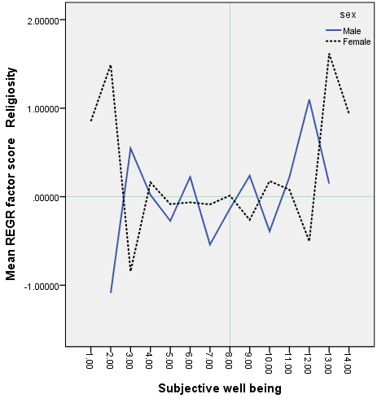 | 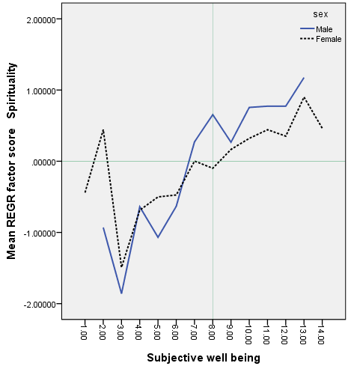
(a) | (b)

Figure 1. Religiousity, spirituality and subjective well being according sex.
The graph gender of (a) religiousity and (b) spiritualit

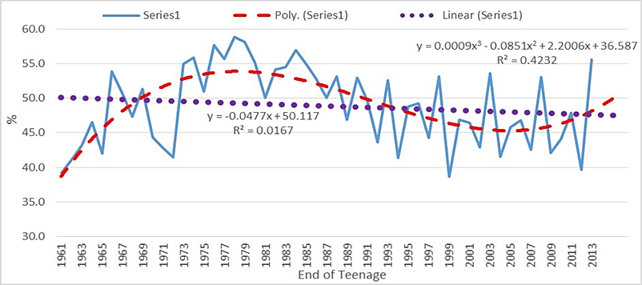

Figure 2. Modelling prevalence of teenage pregnancy 1961-2013

Table 1. Sample distribution
Case | Bangkok | Surabaya | Total
DM | 30 | 30 | 60
HT | 35 | 33 | 68
DM&HT | 35 | 33 | 68
Total | 100 | 96 | 196

- RESULTS AND DISCUSSION (10 PT)
In this section, it is explained the results of research and at the same time is given
the comprehensive discussion. Results can be presented in figures, graphs, tables and others that make
the reader understand easily [14], [15]. The discussion can be made in several sub-sections.

3.1. Sub section 1
Equations should be placed at the center of the line and provided consecutively with equation numbers in parentheses flushed to the right margin, as in (1). The use of Microsoft Equation Editor or MathType is preferred.

$E_{v}-E=\frac{h}{2.m} (k_{x}^{2}+k_{y}^{2}$) (1)

All symbols that have been used in the equations should be defined in the following text.

3.2. Sub section 2
Proper citation of other works should be made to avoid plagiarism. When referring to a reference item, please use the reference number as in [16] or [17] for multiple references. The use of ”Ref [18]...” should be employed for any reference citation at the beginning of sentence. For any reference with more than 3 or more authors, only the first author is to be written followed by et al. (e.g. in [19]). Examples of reference items of different categories shown in the References section. Each item in the references section should be typed using 8 pt font size [20]–[25].

3.2.1. Subsub section 1
yy
3.2.2. Subsub section 2
zz

- CONCLUSION (10 PT)
Provide a statement that what is expected, as stated in the "INTRODUCTION" section can ultimately result in "RESULTS AND DISCUSSION" section, so there is compatibility. Moreover, it can also be added the prospect of the development of research results and application prospects of further studies into the next (based on result and discussion).

ACKNOWLEDGEMENTS (10 PT)
Author thanks ... . In most cases, sponsor and financial support acknowledgments.

REFERENCES (10 PT)
The main references are international journals and proceedings. All references should be to the most pertinent, up-to-date sources and the minimum of references are 25 entries (for original research paper) and 50 entries (for review/survey paper). References are written in IEEE style. For more complete guide can be accessed at (http://ipmuonline.com/guide/refstyle.pdf). Use of a tool such as EndNote, Mendeley, or Zotero for reference management and formatting, and choose IEEE style. Please use a consistent format for references-see examples (8 pt):

- Journal/Periodicals
Basic Format:
J. K. Author, “Title of paper,” Abbrev. Title of Journal/Periodical, vol. x, no. x, pp. xxx-xxx, Abbrev. Month, year, doi: xxx.
Examples:
- M. M. Chiampi and L. L. Zilberti, “Induction of electric field in human bodies moving near MRI: An efficient BEM computational procedure,” IEEE Trans. Biomed. Eng., vol. 58, pp. 2787–2793, Oct. 2011, doi: 10.1109/TBME.2011.2158315.
- R. Fardel, M. Nagel, F. Nuesch, T. Lippert, and A. Wokaun, “Fabrication of organic light emitting diode pixels by laser-assisted forward transfer,” Appl. Phys. Lett., vol. 91, no. 6, Aug. 2007, Art. no. 061103, doi: 10.1063/1.2759475.

- Conference Proceedings
Basic Format:
J. K. Author, “Title of paper,” in Abbreviated Name of Conf., (location of conference is optional), year, pp. xxx–xxx, doi: xxx.
Examples:
- G. Veruggio, “The EURON roboethics roadmap,” in Proc. Humanoids ’06: 6th IEEE-RAS Int. Conf. Humanoid Robots, 2006, pp. 612–617, doi: 10.1109/ICHR.2006.321337.
- J. Zhao, G. Sun, G. H. Loh, and Y. Xie, “Energy-efficient GPU design with reconfigurable in-package graphics memory,” in Proc. ACM/IEEE Int. Symp. Low Power Electron. Design (ISLPED), Jul. 2012, pp. 403–408, doi: 10.1145/2333660.2333752.

- Book
Basic Format:
J. K. Author, “Title of chapter in the book,” in Title of His Published Book, X. Editor, Ed., xth ed. City of Publisher, State (only U.S.), Country: Abbrev. of Publisher, year, ch. x, sec. x, pp. xxx–xxx.
Examples:
- A. Taflove, Computational Electrodynamics: The Finite-Difference Time-Domain Method in Computational Electrodynamics II, vol. 3, 2nd ed. Norwood, MA, USA: Artech House, 1996.
- R. L. Myer, “Parametric oscillators and nonlinear materials,” in Nonlinear Optics, vol. 4, P. G. Harper and B. S. Wherret, Eds., San Francisco, CA, USA: Academic, 1977, pp. 47–160.

- M. Theses (B.S., M.S.) and Dissertations (Ph.D.)
Basic Format:
J. K. Author, “Title of thesis,” M.S. thesis, Abbrev. Dept., Abbrev. Univ., City of Univ., Abbrev. State, year.
J. K. Author, “Title of dissertation,” Ph.D. dissertation, Abbrev. Dept., Abbrev. Univ., City of Univ., Abbrev. State, year.
Examples:
- J. O. Williams, “Narrow-band analyzer,” Ph.D. dissertation, Dept. Elect. Eng., Harvard Univ., Cambridge, MA, USA, 1993.
- N. Kawasaki, “Parametric study of thermal and chemical nonequilibrium nozzle flow,” M.S. thesis, Dept. Electron. Eng., Osaka Univ., Osaka, Japan, 1993.

*In the reference list, however, list all the authors for up to six authors. Use et al. only if: 1) The names are not given and 2) List of authors more than 6. Example: J. D. Bellamy et al., Computer Telephony Integration, New York: Wiley, 2010.

See the examples:
REFERENCES
[1] K. A. Stepien and A. Baernstein, “Educating for empathy: A review,” J. Gen. Intern. Med., vol. 21, no. 5, pp. 524–530, 2006, doi: 10.1111/j.1525-1497.2006.00443.x.
[2] D. Jeffrey and R. Downie, “Empathy-Can it be taught?,” J. R. Coll. Physicians Edinb., vol. 46, no. 2, pp. 107–112, 2016, doi: 10.4997/JRCPE.2016.210.
[3] R. Mathews and C. M. Spencer, “National security strategy for U.S. water,” IEEE Eng. Med. Biol. Mag., vol. 27, no. 6, pp. 42–53, 2008, doi: 10.1109/MEMB.2008.929887.
[4] Y. Azhar and R. Afdian, “Feature selection on pregnancy risk classification using C5.0 method,” Kinetik, vol. 3, no. 4, pp. 345–350, 2018, doi: 10.22219/kinetik.v3i4.703.
[5] L. Buckingham et al., “Going Social: Success in Online Recruitment of Men Who Have Sex with Men for Prevention HIV Vaccine Research,” Vaccine, vol. 35, no. 27, pp. 3498–3505, 2017, doi: 10.1016/j.vaccine.2017.05.002.
[6] J. Bian et al., “Mining Twitter to Assess the Public Perception of the ‘Internet of Things,’” PLoS One, vol. 11, no. 7, 2016, doi: 10.1371/journal.pone.0158450.
[7] R. Valter, S. Santiago, R. Ramos, M. Oliveira, L. O. M. Andrade, and I. C. de H. C. Barreto, “Data Mining and Risk Analysis Supporting Decision in Brazilian Public Health Systems,” 2019, doi: 10.1109/HealthCom46333.2019.9009439.
[8] Y. Liu and H. Wu, “Water bloom warning model based on random forest,” in International Conference on Intelligent Informatics and Biomedical Sciences (ICIIBMS), 2017, pp. 45–48, doi: 10.1109/ICIIBMS.2017.8279712.
[9] P. Deki, “Factors Affecting Early Childhood Growth and Development: Golden 1000 Days,” J. Adv. Pract. Nurs., vol. 01, no. 01, pp. 1–4, 2016, doi: 10.4172/2573-0347.1000101.
[10] C. Nwankwo, P. Ezenduka, E. Chiejina, and S. Igwilo, “Effect of maternal health education on the health attitude of pregnant motherss attending antenatal clinics in Anambraa State Nigeria,” J. Innov. Res. Sci. Eng. Technol., vol. 5, no. 2, pp. 1914–1923, 2016, doi: 10.15680/IJIRSET.2016.0502136.
[11] V. Mohan et al., “Prevention of diabetes in rural India with a telemedicine intervention,” J. Diabetes Sci. Technol., vol. 6, no. 6, pp. 1355–1364, 2012, doi: 10.1177/193229681200600614.
[12] V. V. Klimontov, N. V. Tyan, O. N. Fazullina, N. E. Myakina, A. P. Lykov, and V. I. Konenkov, “Clinical and metabolic factors associated with chronic low-grade inflammation in type 2 diabetic patients,” Diabetes Mellit., vol. 19, no. 4, pp. 295–302, 2016, doi: 10.14341/DM7928.
[13] M. Feng and S. Jia, “Dual effect of WISP-1 in diverse pathological processes,” Chinese J. Cancer Res., vol. 28, no. 6, pp. 553–560, 2016, doi: 10.21147/j.issn.1000-9604.2016.06.01.
[14] M. B. Hayes and W. Aspray, “Relational Agents for Chronic Disease Self-Management,” in Health Informatics: A Patient-Centered Approach to Diabetes, MIT Press Scholarship, 2010, pp. 181–204.
[15] I. Barchetta et al., “WISP1 Is a Marker of Systemic and Adipose Tissue Inflammation in Dysmetabolic Subjects With or Without Type 2 Diabetes,” J. Endocr. Soc., vol. 1, no. 6, pp. 660–670, 2017, doi: 10.1210/js.2017-00108.
[16] K. Zarkogianni, M. Athanasiou, A. C. Thanopoulou, and K. S. Nikita, “Comparison of Machine Learning Approaches Toward Assessing the Risk of Developing Cardiovascular Disease as a Long-Term Diabetes Complication,” IEEE J. Biomed. Heal. Informatics, vol. 22, no. 5, 2018, doi: 10.1109/JBHI.2017.2765639.
[17] H. T. Nguyen, N. Ghevondian, and T. W. Jones, “Neural-Network Detection of Hypoglycemic Episodes in Children with Type 1 Diabetes using Physiological Parameters,” in 2006 International Conference of the IEEE Engineering in Medicine and Biology Society, 2006, pp. 6053–6056, doi: 10.1109/IEMBS.2006.259482.
[18] M. D. Breton, L. S. Farhy, J. K. Penberthy, and B. P. Kovatchev, “Bio-Behavioral Control, Glucose Variability, and Hypoglycemia-Associated Autonomic Failure in Type 1 Diabetes (T1DM),” in 2006 International Conference of the IEEE Engineering in Medicine and Biology Society, 2006, pp. 315–318, doi: 10.1109/IEMBS.2006.260113.
[19] A. J. Rogers, J. M. Miller, R. Kannappan, and P. Sethu, “Cardiac Tissue Chips (CTCs) for Modeling Cardiovascular Disease,” IEEE Trans. Biomed. Eng., vol. 66, no. 12, pp. 3436–3443, 2019, doi: 10.1109/TBME.2019.2905763.
[20] M. F. Yahya and E. Supriyanto, “Physiological modeling of sound effect on neuro-cardiovascular system,” in 2016 International Conference on Robotics, Automation and Sciences (ICORAS), 2016, pp. 1–4, doi: 10.1109/ICORAS.2016.7872619.
[21] R. M. Conroy, K. Pyorala, and A. P. Fitzgerald, “Estimation Of Ten-Year Risk Cardiovascular Disease In Europe: The SCORE Project,” Eur. Heart J., vol. 24, pp. 987–1003, 2003, doi: 10.1016/S0195-668X(03)00114-3.
[22] P. Pagliaro, C. Penna, and R. Rastaldo, “Basic Cardiovascular Physiology: From Molecules to Translational Medical Science,” in Basic Cardiovascular Physiology: From Molecules to Translational Medical Science, River Publishers, 2020, pp. 1–24.
[23] R. Corti and V. Fuster, “Imaging of atherosclerosis: Magnetic resonance imaging,” Eur. Heart J., vol. 32, no. 14, pp. 1709–1719, 2011, doi: 10.1093/eurheartj/ehr068.
[24] S. Achenbach, “Can CT detect the vulnerable coronary plaque?,” Int. J. Cardiovasc. Imaging, vol. 24, no. 3, pp. 311–312, 2008, doi: 10.1007/s10554-007-9281-1.
[25] E. Supriyanto, “The future of cardiovascular imaging,” 2015 4th International Conference on Instrumentation, Communications, Information Technology, and Biomedical Engineering (ICICI-BME), 2015, doi: 10.1109/ICICI-BME.2015.7401302.

BIOGRAPHIES OF AUTHORS (10 PT)

The recommended number of authors is at least 2. One of them as a corresponding author.
Please attach clear photo (3x4 cm) and vita. Example of biographies of authors:

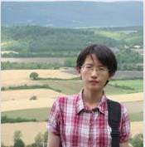 | Yu-Tzu Wu is an epidemiologist/statistician working on the Improving the Experience of Dementia and Enhancing Active Life (IDEAL) project, a longitudinal cohort focusing on quality of life and wellbeing in people with dementia and their carers across the United Kingdom. I am interested in exploring environmental determinants of health and wellbeing in later life. He can be contacted at email: Y.Wu3@exeter.ac.uk.
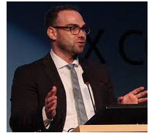 | David Stuckler is a Full Professor of Policy Analysis and Public Management at Bocconi University in Milan and an Intellectual Forum Senior Research Associate at Jesus College, Cambridge. Before, he has been a Professor of Political Economy and Sociology and a Senior Research Leader at Oxford University. He has published over one hundred peer-reviewed scientific articles in major journals on the subjects of economics and global health, and his work has featured on the cover of The New York Times and The Economist, as well as on BBC, NPR, and CNN, among others. He has written the books The Body Economic and Sick Societies. He can be contacted at email: david.stuckler@unibocconi.it.
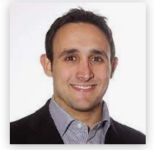 | Gaetano Isola is a Researcher Assistant of Clinical Odontostomatology, School of Dentistry, University of Messina, Italy. DDS at the University of Messina. PhD in “Phisiopathology of the Stomatognatic Apparatus and Dental Materials” at the University of Turin, Italy. Researcher fellow at the “Laboratory the Study of Calcified Tissues and Biomaterials” and “Department of Periodontology” Université de Montréal. Advanced Course in Periodontology, University of Ferrara. Master Course University of Verona, 2014. Involved with several research projects in the field of the periodontology, oral surgery and orthodontics. His research interests are mainly focused on the physiopathology of Periodontal Diseases and the jaw muscles, craniofacial growth, the aetiology and management of the different malocclusion and the relationship between jaw musculature and orthodontics. Active member of The European Orthodontic Society (EOS), IADR and member of the Italian Society of Periodontology (SIdP). Author of several international peer reviewed publications about orthodontics, masticatory function and periodontology. He can be contacted at email: gaetano.isola@unict.it

