Paper’s title should be the fewest possible words that accurately describe the content of the paper (Center, Bold, 16pt)

Tole Sutikno^{1,2}, Chuen Ling Toh³, Frede Blaabjerg⁴ (10 pt)
¹Department of Electrical Engineering, Faculty of Industrial Technology, Universitas Ahmad Dahlan, Yogyakarta, Indonesia (8 pt)
²Embedded System and Power Electronics Research Group, Yogyakarta, Indonesia
³Department of Electrical and Electronic Engineering, College of Engineering, Universiti Tenaga National, Kajang, Malaysia
⁴Department of Energy Technology, Faculty of Engineering Science, Aalborg University, Aalborg, Denmark

Article Info |  | ABSTRACT (10 PT)
Article history:  Received mm dd, yyyy  Revised mm dd, yyyy  Accepted mm dd, yyyy |  | An abstract is often presented separate from the article, so it must be able to stand alone. A well-prepared abstract enables the reader to identify the basic content of a document quickly and accurately, to determine its relevance to their interests, and thus to decide whether to read the document in its entirety. The abstract should be informative and completely self-explanatory, provide a clear statement of the problem, the proposed approach or solution, and point out major findings and conclusions. The Abstract should be 100 to 200 words in length. References should be avoided, but if essential, then cite the author(s) and year(s). Standard nomenclature should be used, and non-standard or uncommon abbreviations should be avoided, but if essential they must be defined at their first mention in the abstract itself. No literature should be cited. The keyword list provides the opportunity to add 5 to 7 keywords, used by the indexing and abstracting services, in addition to those already present in the title (9 pt).
Keywords:
First keyword
Second keyword
Third keyword
Fourth keyword
Fifth keyword
 |  | This is an open access article under the CC BY-SA license.
Corresponding Author:
Tole Sutikno
Department of Electrical Engineering, Faculty of Industrial Technology, Universitas Ahmad Dahlan
4th UAD Campus, Ahmad Yani St. (Southern Ring Road), Tamanan, Yogyakarta 55191, Indonesia
Email: tole@mail.com

- INTRODUCTION (10 PT)
The main text format consists of a flat left-right columns on A4 paper (quarto). The margin text from the left and top are 2.5 cm, right and bottom are 2 cm. The manuscript is written in Microsoft Word, single space, Time New Roman 10 pt, and maximum 12 pages for original research article, or maximum 16 pages for review/survey paper, which can be downloaded at the website: http://ijpeds.iaescore.com.
A title of article should be the fewest possible words that accurately describe the content of the paper. The title should be succinct and informative and no more than about 12 words in length. Do not use acronyms or abbreviations in your title and do not mention the method you used, unless your paper reports on the development of a new method. Titles are often used in information-retrieval systems. Avoid writing long formulas with subscripts in the title. Omit all waste words such as "A study of ...", "Investigations of ...", "Implementation of ...”, "Observations on ...", "Effect of.....", “Analysis of …”, “Design of…”, etc.
A concise and factual abstract is required. The abstract should state briefly the purpose of the research, the principal results and major conclusions. An abstract is often presented separately from the article, so it must be able to stand alone. For this reason, References should be avoided, but if essential, then cite the author(s) and year(s). Also, non-standard or uncommon abbreviations should be avoided, but if essential they must be defined at their first mention in the abstract itself. Immediately after the abstract, provide a maximum of 7 keywords, using American spelling and avoiding general and plural terms and multiple concepts (avoid, for example, 'and', 'of'). Be sparing with abbreviations: only abbreviations firmly established in the field may be eligible. These keywords will be used for indexing purposes.
Indexing and abstracting services depend on the accuracy of the title, extracting from it keywords useful in cross-referencing and computer searching. An improperly titled paper may never reach the audience for which it was intended, so be specific.
The Introduction section should provide: i) a clear background, ii) a clear statement of the problem, iii) the relevant literature on the subject, iv) the proposed approach or solution, and v) the new value of research which it is innovation (within 3-6 paragraphs). It should be understandable to colleagues from a broad range of scientific disciplines. Organization and citation of the bibliography are made in Institute of Electrical and Electronics Engineers (IEEE) style in sign [1], [2] and so on. The terms in foreign languages are written italic (italic). The text should be divided into sections, each with a separate heading and numbered consecutively [3]. The section or subsection headings should be typed on a separate line, e.g., 1. INTRODUCTION. A full article usually follows a standard structure: 1. Introduction, 2. The Comprehensive Theoretical Basis and/or the Proposed Method/Algorithm (optional), 3. Method,
4. Results and Discussion, and 5. Conclusion. The structure is well-known as IMRaD style.
Literature review that has been done author used in the section "INTRODUCTION" to explain
the difference of the manuscript with other papers, that it is innovative, it are used in the section "METHOD" to describe the step of research and used in the section "RESULTS AND DISCUSSION" to support the analysis of the results [2]. If the manuscript was written really have high originality, which proposed a new method or algorithm, the additional section after the "INTRODUCTION" section and before the "METHOD" section can be added to explain briefly the theory and/or the proposed method/algorithm [4].

- METHOD (10 PT)
Explaining research chronological, including research design, research procedure (in the form of algorithms, Pseudocode or other), how to test and data acquisition [5]–[7]. The description of the course of research should be supported references, so the explanation can be accepted scientifically [3], [4]. Figures 1-2 and Table 1 are presented center, as shown below and cited in the manuscript [5], [8]–[13]. Figure 2 shows the effect of series resistances on the (a) I-V and (b) P-V characteristics.

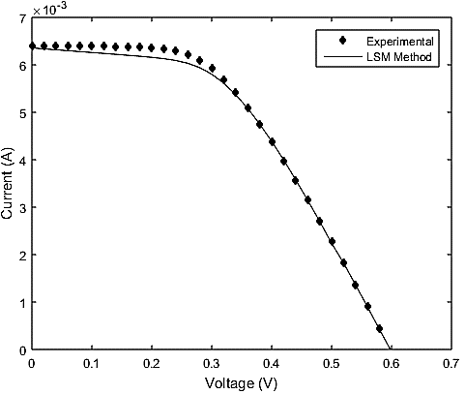

Figure 1. Calculated and experimental I-V characteristics of P3HT: PCBM polymer solar cell

Table 1. The performance of ...
Variable | Speed (rpm) | Power (kW)
x | 10 | 8.6
y | 15 | 12.4
z | 20 | 15.3

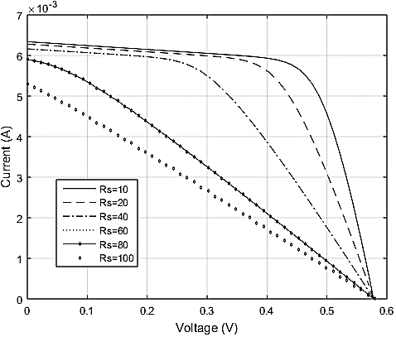
(a)

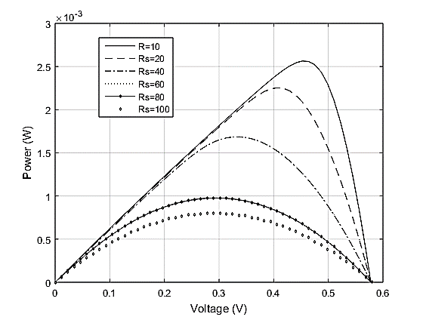
(b)

Figure 2. Effect of series resistances on the (a) I-V and (b) P-V characteristics

- RESULTS AND DISCUSSION (10 PT)
In this section, it is explained the results of research and at the same time is given
the comprehensive discussion. Results can be presented in figures, graphs, tables and others that make
the reader understand easily [14], [15]. The discussion can be made in several sub-sections.

3.1. Sub section 1
Equations should be placed at the center of the line and provided consecutively with equation numbers in parentheses flushed to the right margin, as in (1). The use of Microsoft Equation Editor or MathType is preferred.

$E_{v}-E=\frac{h}{2.m} (k_{x}^{2}+k_{y}^{2}$) (1)

All symbols that have been used in the equations should be defined in the following text.

3.2. Sub section 2
Proper citation of other works should be made to avoid plagiarism. When referring to a reference item, please use the reference number as in [16] or [17] for multiple references. The use of ”Ref [18]...” should be employed for any reference citation at the beginning of sentence. For any reference with more than 3 or more authors, only the first author is to be written followed by et al. (e.g. in [19]). Examples of reference items of different categories shown in the References section. Each item in the references section should be typed using 8 pt font size [20]–[25].

3.2.1. Subsub section 1
yy
3.2.2. Subsub section 2
zz

- CONCLUSION (10 PT)
Provide a statement that what is expected, as stated in the "INTRODUCTION" section can ultimately result in "RESULTS AND DISCUSSION" section, so there is compatibility. Moreover, it can also be added the prospect of the development of research results and application prospects of further studies into the next (based on result and discussion).

ACKNOWLEDGEMENTS (10 PT)
Author thanks ... . In most cases, sponsor and financial support acknowledgments.

REFERENCES (10 PT)
The main references are international journals and proceedings. All references should be to the most pertinent, up-to-date sources and the minimum of references are 25 entries (for original research paper) and 50 entries (for review paper). References are written in IEEE style. For more complete guide can be accessed at (http://ipmuonline.com/guide/refstyle.pdf). Use of a tool such as EndNote, Mendeley, or Zotero for reference management and formatting, and choose IEEE style. Please use a consistent format for references-see examples (8 pt):

- Journal/Periodicals
Basic Format:
J. K. Author, “Title of paper,” Abbrev. Title of Journal/Periodical, vol. x, no. x, pp. xxx-xxx, Abbrev. Month, year, doi: xxx.
Examples:
- M. M. Chiampi and L. L. Zilberti, “Induction of electric field in human bodies moving near MRI: An efficient BEM computational procedure,” IEEE Trans. Biomed. Eng., vol. 58, pp. 2787–2793, Oct. 2011, doi: 10.1109/TBME.2011.2158315.
- R. Fardel, M. Nagel, F. Nuesch, T. Lippert, and A. Wokaun, “Fabrication of organic light emitting diode pixels by laser-assisted forward transfer,” Appl. Phys. Lett., vol. 91, no. 6, Aug. 2007, Art. no. 061103, doi: 10.1063/1.2759475.

- Conference Proceedings
Basic Format:
J. K. Author, “Title of paper,” in Abbreviated Name of Conf., (location of conference is optional), year, pp. xxx–xxx, doi: xxx.
Examples:
- G. Veruggio, “The EURON roboethics roadmap,” in Proc. Humanoids ’06: 6th IEEE-RAS Int. Conf. Humanoid Robots, 2006, pp. 612–617, doi: 10.1109/ICHR.2006.321337.
- J. Zhao, G. Sun, G. H. Loh, and Y. Xie, “Energy-efficient GPU design with reconfigurable in-package graphics memory,” in Proc. ACM/IEEE Int. Symp. Low Power Electron. Design (ISLPED), Jul. 2012, pp. 403–408, doi: 10.1145/2333660.2333752.

- Book
Basic Format:
J. K. Author, “Title of chapter in the book,” in Title of His Published Book, X. Editor, Ed., xth ed. City of Publisher, State (only U.S.), Country: Abbrev. of Publisher, year, ch. x, sec. x, pp. xxx–xxx.
Examples:
- A. Taflove, Computational Electrodynamics: The Finite-Difference Time-Domain Method in Computational Electrodynamics II, vol. 3, 2nd ed. Norwood, MA, USA: Artech House, 1996.
- R. L. Myer, “Parametric oscillators and nonlinear materials,” in Nonlinear Optics, vol. 4, P. G. Harper and B. S. Wherret, Eds., San Francisco, CA, USA: Academic, 1977, pp. 47–160.

- M. Theses (B.S., M.S.) and Dissertations (Ph.D.)
Basic Format:
J. K. Author, “Title of thesis,” M.S. thesis, Abbrev. Dept., Abbrev. Univ., City of Univ., Abbrev. State, year.
J. K. Author, “Title of dissertation,” Ph.D. dissertation, Abbrev. Dept., Abbrev. Univ., City of Univ., Abbrev. State, year.
Examples:
- J. O. Williams, “Narrow-band analyzer,” Ph.D. dissertation, Dept. Elect. Eng., Harvard Univ., Cambridge, MA, USA, 1993.
- N. Kawasaki, “Parametric study of thermal and chemical nonequilibrium nozzle flow,” M.S. thesis, Dept. Electron. Eng., Osaka Univ., Osaka, Japan, 1993.

*In the reference list, however, list all the authors for up to six authors. Use et al. only if: 1) The names are not given and 2) List of authors more than 6. Example: J. D. Bellamy et al., Computer Telephony Integration, New York: Wiley, 2010.

See the examples:
REFERENCES
[1] D. Jovcic, “Series LC DC circuit breaker,” High Volt., vol. 4, no. 2, pp. 130–137, Jun. 2019, doi: 10.1049/hve.2019.0003.
[2] P. Pareek and H. D. Nguyen, “Probabilistic robust small-signal stability framework using gaussian process learning,” Electr. Power Syst. Res., vol. 188, pp. 1–7, 2020, doi: 10.1016/j.epsr.2020.106545.
[3] S. Leonelli and N. Tempini, Data Journeys in the Sciences. Springer.
[4] G. Nguyen et al., “Machine Learning and Deep Learning frameworks and libraries for large-scale data mining: a survey,” Artif. Intell. Rev., vol. 52, no. 1, pp. 77–124, 2019, doi: 10.1007/s10462-018-09679-z.
[5] R. Vinayakumar, M. Alazab, K. P. Soman, P. Poornachandran, A. Al-Nemrat, and S. Venkatraman, “Deep Learning Approach for Intelligent Intrusion Detection System,” IEEE Access, vol. 7, pp. 41525–41550, 2019, doi: 10.1109/ACCESS.2019.2895334.
[6] K. Sivaraman, R. M. V. Krishnan, B. Sundarraj, and S. Sri Gowthem, “Network failure detection and diagnosis by analyzing syslog and SNS data: Applying big data analysis to network operations,” Int. J. Innov. Technol. Explor. Eng., vol. 8, no. 9 Special Issue 3, pp. 883–887, 2019, doi: 10.35940/ijitee.I3187.0789S319.
[7] A. D. Dwivedi, G. Srivastava, S. Dhar, and R. Singh, “A decentralized privacy-preserving healthcare blockchain for IoT,” Sensors, vol. 19, no. 2, pp. 1–17, 2019, doi: 10.3390/s19020326.
[8] F. Al-Turjman, H. Zahmatkesh, and L. Mostarda, “Quantifying uncertainty in internet of medical things and big-data services using intelligence and deep learning,” IEEE Access, vol. 7, pp. 115749–115759, 2019, doi: 10.1109/ACCESS.2019.2931637.
[9] S. Kumar and M. Singh, “Big data analytics for healthcare industry: Impact, applications, and tools,” Big Data Min. Anal., vol. 2, no. 1, pp. 48–57, 2019, doi: 10.26599/BDMA.2018.9020031.
[10] L. M. Ang, K. P. Seng, G. K. Ijemaru, and A. M. Zungeru, “Deployment of IoV for Smart Cities: Applications, Architecture, and Challenges,” IEEE Access, vol. 7, pp. 6473–6492, 2019, doi: 10.1109/ACCESS.2018.2887076.
[11] B. P. Lik Lau et al., “A survey of data fusion in smart city applications,” Inf. Fusion, vol. 52, pp. 357–374, 2019, doi: 10.1016/j.inffus.2019.05.004.
[12] Y. Wu et al., “Large scale incremental learning,” Proc. IEEE Comput. Soc. Conf. Comput. Vis. Pattern Recognit., vol. 2019-June, pp. 374–382, 2019, doi: 10.1109/CVPR.2019.00046.
[13] A. Mosavi, S. Shamshirband, E. Salwana, K. Chau, and J. H. M. Tah, “Prediction of multi-inputs bubble column reactor using a novel hybrid model of computational fluid dynamics and machine learning,” Eng. Appl. Comput. Fluid Mech., vol. 13, no. 1, pp. 482–492, 2019, doi: 10.1080/19942060.2019.1613448.
[14] V. Palanisamy and R. Thirunavukarasu, “Implications of big data analytics in developing healthcare frameworks – A review,” J. King Saud Univ. - Comput. Inf. Sci., vol. 31, no. 4, pp. 415–425, 2019, doi: 10.1016/j.jksuci.2017.12.007.
[15] J. Sadowski, “When data is capital: Datafication, accumulation, and extraction,” Big Data Soc., vol. 6, no. 1, pp. 1–12, 2019, doi: 10.1177/2053951718820549.
[16] J. R. Saura, B. R. Herraez, and A. Reyes-Menendez, “Comparing a traditional approach for financial brand communication analysis with a big data analytics technique,” IEEE Access, vol. 7, pp. 37100–37108, 2019, doi: 10.1109/ACCESS.2019.2905301.
[17] D. Nallaperuma et al., “Online Incremental Machine Learning Platform for Big Data-Driven Smart Traffic Management,” IEEE Trans. Intell. Transp. Syst., vol. 20, no. 12, pp. 4679–4690, 2019, doi: 10.1109/TITS.2019.2924883.
[18] S. Schulz, M. Becker, M. R. Groseclose, S. Schadt, and C. Hopf, “Advanced MALDI mass spectrometry imaging in pharmaceutical research and drug development,” Curr. Opin. Biotechnol., vol. 55, pp. 51–59, 2019, doi: 10.1016/j.copbio.2018.08.003.
[19] C. Shang and F. You, “Data Analytics and Machine Learning for Smart Process Manufacturing: Recent Advances and Perspectives in the Big Data Era,” Engineering, vol. 5, no. 6, pp. 1010–1016, 2019, doi: 10.1016/j.eng.2019.01.019.
[20] Y. Yu, M. Li, L. Liu, Y. Li, and J. Wang, “Clinical big data and deep learning: Applications, challenges, and future outlooks,” Big Data Min. Anal., vol. 2, no. 4, pp. 288–305, 2019, doi: 10.26599/BDMA.2019.9020007.
[21] M. Huang, W. Liu, T. Wang, H. Song, X. Li, and A. Liu, “A queuing delay utilization scheme for on-path service aggregation in services-oriented computing networks,” IEEE Access, vol. 7, pp. 23816–23833, 2019, doi: 10.1109/ACCESS.2019.2899402.
[22] G. Xu, Y. Shi, X. Sun, and W. Shen, “Internet of things in marine environment monitoring: A review,” Sensors (Switzerland), vol. 19, no. 7, pp. 1–21, 2019, doi: 10.3390/s19071711.
[23] M. Aqib, R. Mehmood, A. Alzahrani, I. Katib, A. Albeshri, and S. M. Altowaijri, “Smarter Traffic Prediction Using Big Data, In-Memory Computing, Deep Learning and GPUs,” Sensors, vol. 19, no. 9, pp. 2206–2239, 2019, doi: 10.3390/s19092206.
[24] N. Stylos and J. Zwiegelaar, “Big Data as a Game Changer: How Does It Shape Business Intelligence Within a Tourism and Hospitality Industry Context?,” in Big Data and Innovation in Tourism, Travel, and Hospitality, Singapore: Springer, 2019, pp. 163–181.
[25] Q. Song, H. Ge, J. Caverlee, and X. Hu, “Tensor Completion Algorithms in Big Data Analytics,” ACM Trans. Knowl. Discov. Data, vol. 13, no. 1, pp. 1–48, Jan. 2019, doi: 10.1145/3278607.

BIOGRAPHIES OF AUTHORS (10 PT)

The recommended number of authors is at least 2. One of them as a corresponding author.
Please attach clear photo (3x4 cm) and vita. Example of biographies of authors (9 pt):

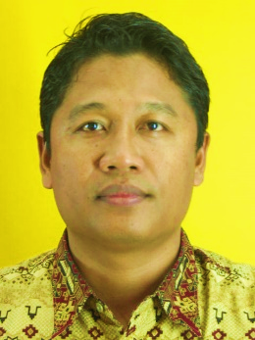 | Tole Sutikno is a lecturer in Electrical Engineering Department at the Universitas Ahmad Dahlan (UAD), Yogyakarta, Indonesia. He received his B.Eng., M.Eng. and Ph.D. degrees in Electrical Engineering from Universitas Diponegoro, Universitas Gadjah Mada and Universiti Teknologi Malaysia, in 1999, 2004 and 2016, respectively. He has been an Associate Professor in UAD, Yogyakarta, Indonesia since 2008. He is currently an Editor-in-Chief of the TELKOMNIKA and the Head of the Embedded Systems and Power Electronics Research Group. His research interests include the field of digital design, industrial applications, industrial electronics, industrial informatics, power electronics, motor drives, renewable energy, FPGA applications, embedded system, artificial intelligence, intelligent control and digital library. He can be contacted at email: tole@ee.uad.ac.id.
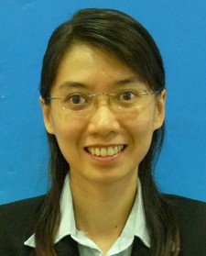 | Chuen Ling Toh is a lecturer in Electrical & Electronic Engineering Department, Universiti Tenaga Nasional, Malaysia since 2008; and she has been a senior lecturer since 2015. She received the B.Eng. degree in electrical engineering and the M.Eng. degree in power electronics, both from Universiti Teknologi Malaysia, Skudai, Malaysia, in 2002 and 2005, respectively; and Ph.D. degree in Electrical Power Engineering from Norwegian University of Science and Technology in 2014. She was with Intel Microelectronics (M) Sdn. Bhd., Halaman Kampung Jawa, Malaysia, as a component design engineer since 2005 to 2008. She is also a member of the Board of Engineers Malaysia and the Malaysia Board of Technologists. Her research interests include the field of power electronics, motor drives, industrial applications, industrial electronics, photovoltaic power systems, digital design, front-end RTL logic design and field programmable gate array applications. She can be contacted at email: tohchuenling@yahoo.com
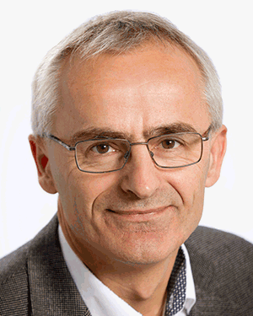 | Frede Blaabjerg was with ABB-Scandia, Randers, Denmark, from 1987 to 1988. From 1988 to 1992, he got the PhD degree in Electrical Engineering at Aalborg University in 1995. He became an Assistant Professor in 1992, an Associate Professor in 1996, and a Full Professor of power electronics and drives in 1998. From 2017 he became a Villum Investigator. He is honoris causa at University Politehnica Timisoara (UPT), Romania and Tallinn Technical University (TTU) in Estonia. His current research interests include power electronics and its applications such as in wind turbines, PV systems, reliability, harmonics and adjustable speed drives. He has published more than 600 journal papers in the fields of power electronics and its applications. He is the co-author of four monographs and editor of ten books in power electronics and its applications. He can be contacted at email: fbl@energy.aau.dk

